Updated: 2022
ICA Volunteer Handbook
Thank you for
volunteering at ICA!

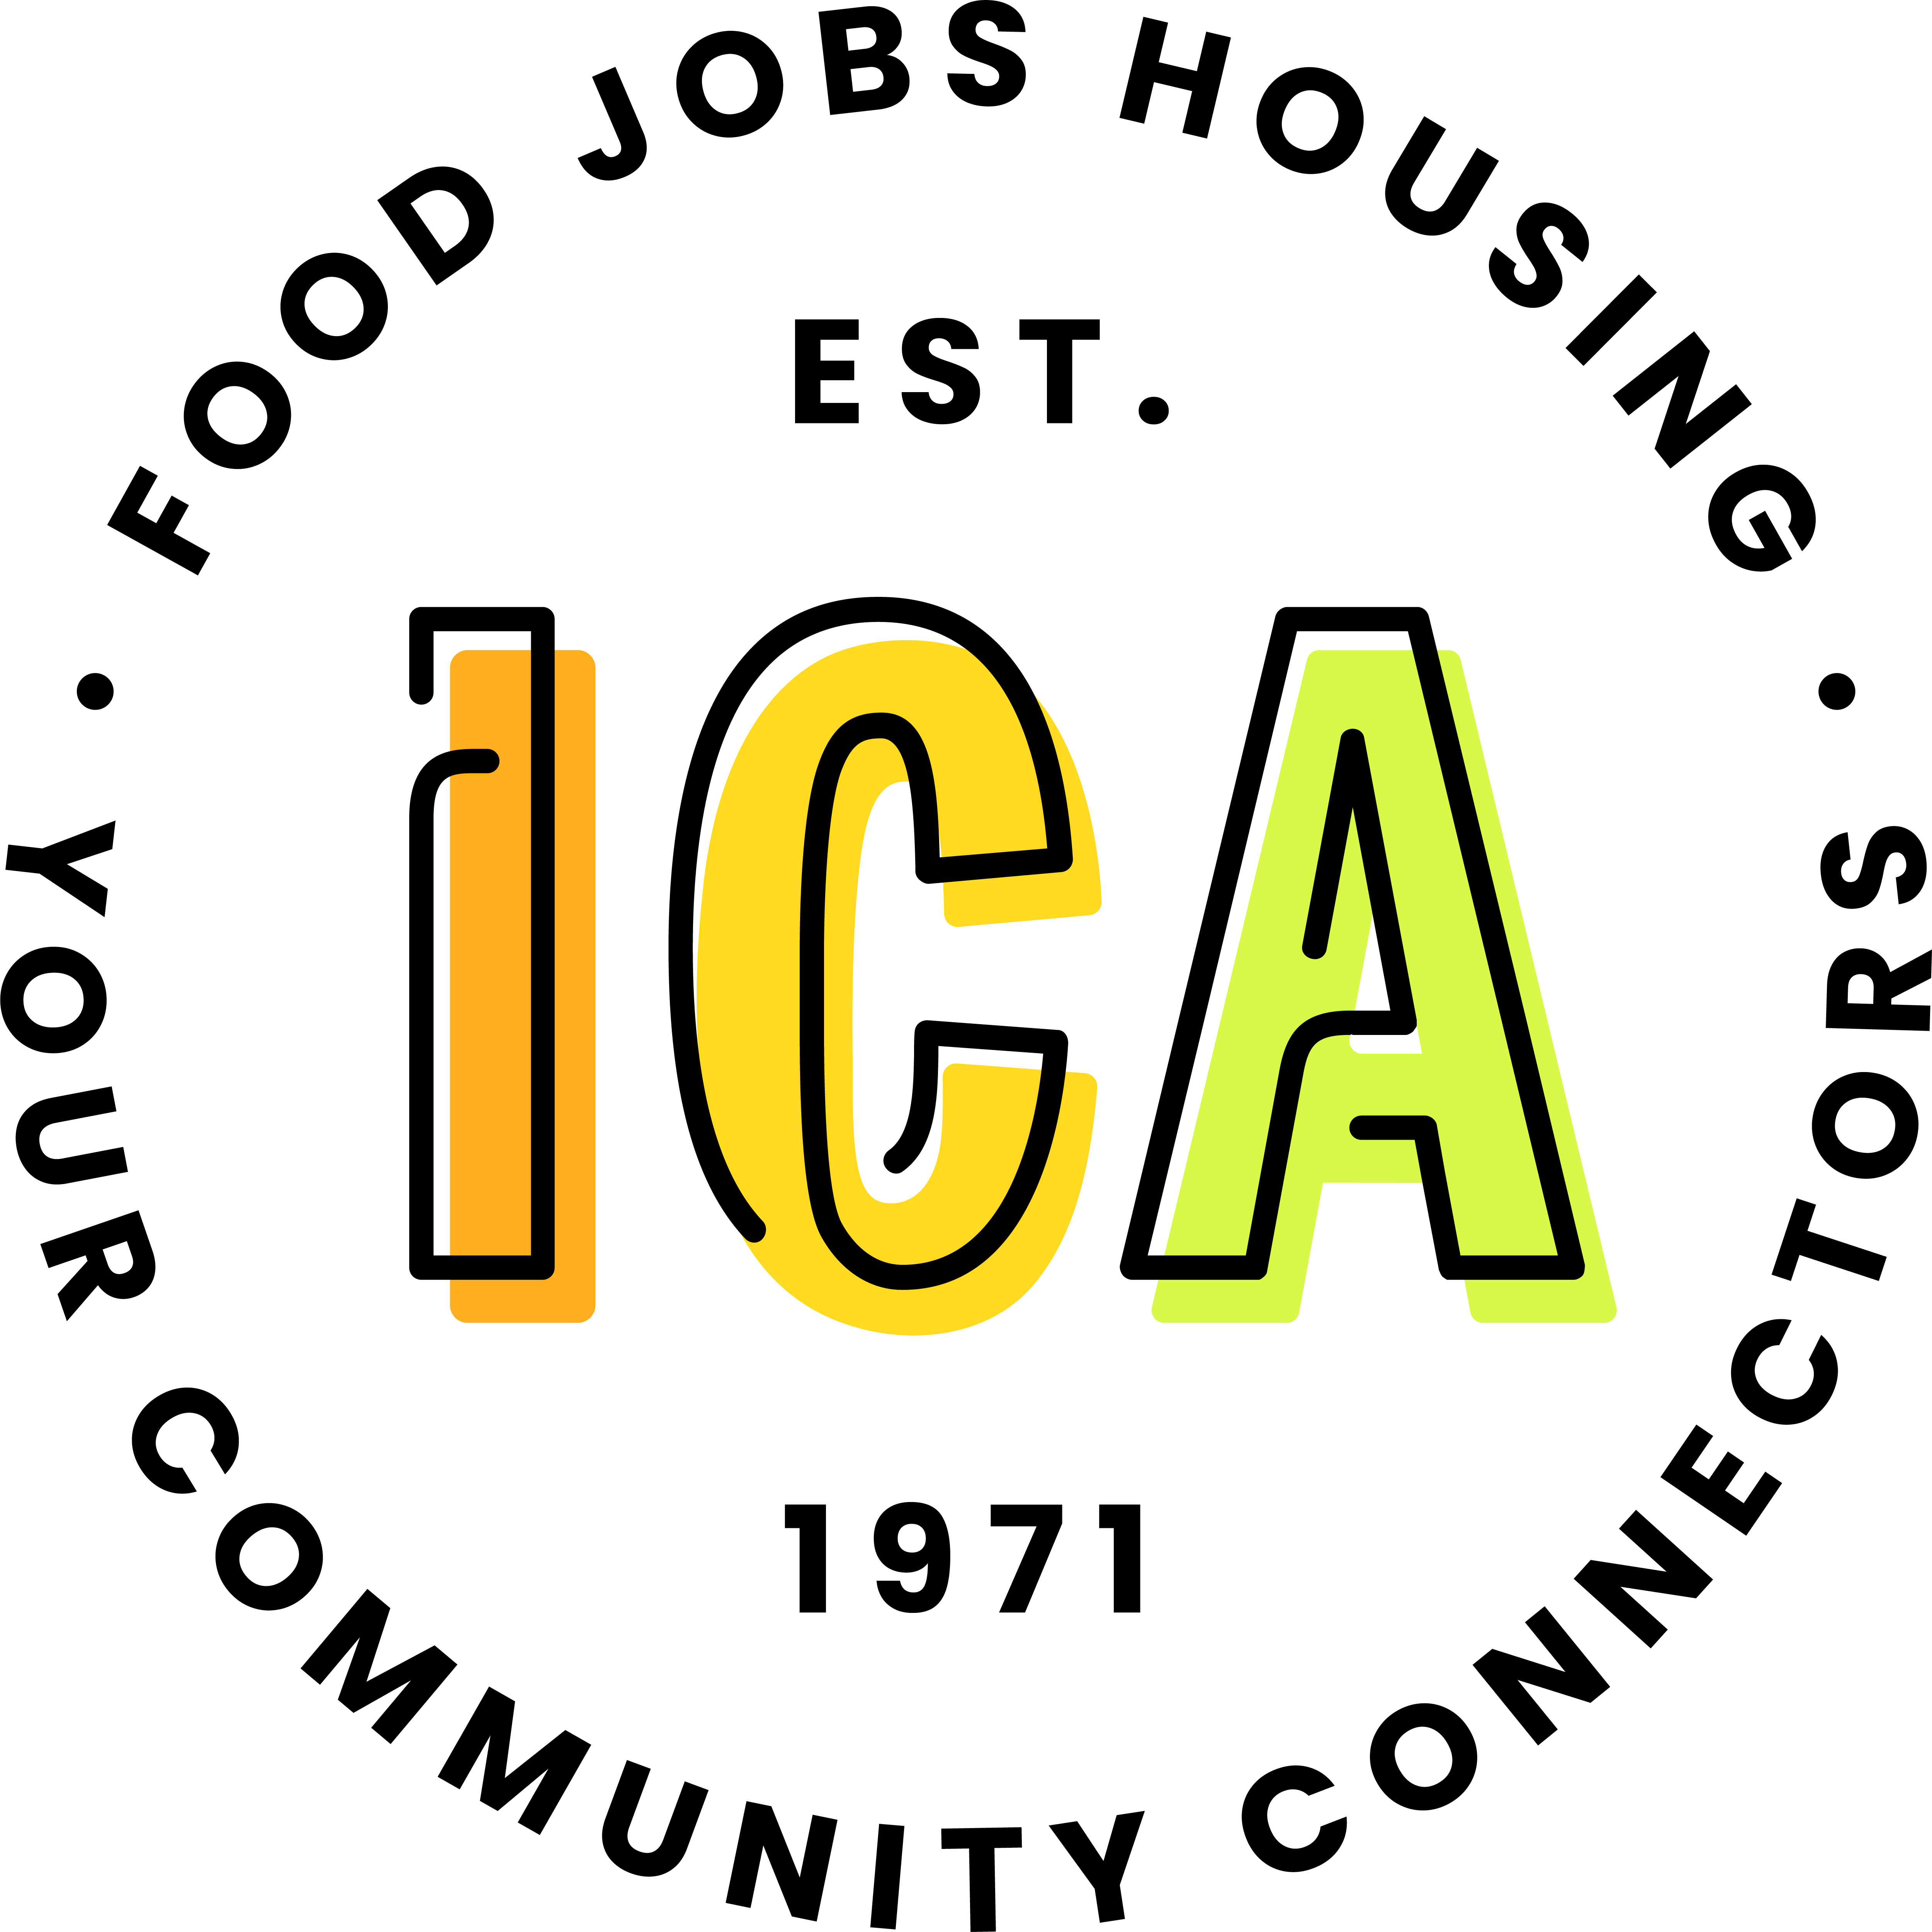
Contents
A NOTE FROM THE DIRECTOR - 3 -
WELCOME TO ICA - 3 -
Our Mission - 3 -
Our Vision - 3 -
Our Belief - 3 -
IMPORTANT NOTES AND EXPECTATIONS ABOUT WORKING AT ICA - 4 -
Food Room Notes - 4 -
Front Desk Notes - 4 -
SCHEDULING GUIDELINES - 5 -
PARKING GUIDELINES - 5 -
VOLUNTEERING FRINGE BENEFITS - 6 -
MANAGING VERBALLY AGGRESSIVE NEIGHBORS - 6 -
CODE OF CONDUCT - 6 -
CONFIDENTIALITY - 7 -
NEIGHBORS AS VOLUNTEERS - 7 -
OTHER WAYS TO GET INVOLVED - 7 -
Special Projects - 7 -
Donate to ICA - 8 -
Do a Food or Hygiene Drive - 8 -
APPENDIX A - GETTING TO KNOW THE ICA STAFF - 9 -
APPENDIX B – GENERAL INSIGHTS ON ICA’S NEIGHBORS IN NEED - 11 -
Understanding Poverty - 11 -
Generational Poverty - 11 -
New Poverty - 11 -
Generational Versus New Poverty - 11 -
Understanding the Various Cultures We Serve - 11 -
How People Might Be Feeling When They Come To ICA - 12 -
APPENDIX C - VOLUNTEER OPPORTUNITY DESCRIPTIONS - 13 -

A NOTE FROM THE DIRECTOR
Thank you for your interest in volunteering at ICA – we believe that the work done at ICA makes our neighbors stronger and more stable. Your work here, no matter what the task, will get us that much closer to meeting and exceeding that goal. Each day when I walk into our building I am reminded that working here is a privilege and an honor as we find ways to assist our neighbors who are looking for ways to make ends meet – we are their bridge!
My office door is always open as am I to new ideas and ways to do our work more effectively; stop by anytime.
With gratitude,
Dan Narr
Executive Director

WELCOME TO ICA
The work accomplished day in and day out at ICA can only happen with the help of amazing volunteers. Every day about 20 full-time and part-time staff, along with over 50 volunteers, make food, job coaching, and financial assistance available to ICA’s neighbors. In 2020, each month ICA served an average of 900 households who received assistance. The need is great, and you are playing a key role in providing this greatly needed assistance to people in our local community who are in need. Thank you!
ICA has served the communities of Hopkins, Minnetonka, Excelsior, Shorewood, Greenwood, Deephaven and Woodland since 1971. We deeply value equal respect for one another as well as effective partnership to get the work done. As such, we hold our volunteers to this same standard, expecting that you will treat neighbors with the utmost respect and work alongside one another and the ICA staff as a team, in partnership with one another. This will go a long way in keeping the various aspects of ICA’s work to be the very best and reaching the goal of serving neighbors as well as we possibly can.
We are an intentionally strategic and professional organization that values innovation and regular evaluation and improvement. We scrutinize our spending and strive to manage our resources, time, and finances to achieve narrowly-focused, community-driven goals. We take very seriously our role in the community to provide for our neighbors in need, while balancing this with an appropriate sense of humor and a hopefulness that we can and are making a tangible impact each and every day.

Our Mission
To create a healthy and stable community for all.

Our Vision
A community where everyone has the resources to thrive.

Our Belief
ICA’s presence in our communities makes our neighborhoods more stable and secure.

IMPORTANT NOTES AND EXPECTATIONS ABOUT WORKING AT ICA
- Treat every neighbor, every time, as though it’s the first time they have come to ICA. This gives them a fresh chance to interact with you in a pleasant manner. This can be difficult, especially if you have had a poor experience with the neighbor in the past, but it is our goal and responsibility to serve them and show them kindness and consideration each time they come.
- A spirit of teamwork and positive attitudes are very important at ICA. They help tremendously when working with other volunteers, staff, and neighbors. We encourage you to bring this mentality with you when working at ICA, while also encouraging others to do the same.
- Flexibility is central to ICA’s culture. We hold the expectation that all staff and volunteers will value and maintain an attitude of flexibility.
- ICA is known as an innovative food shelf and a leader among food shelves in the metro area. We value creativity, open communication, honesty, and regular evaluation of the way we operate. We hope you will be open and honest about your volunteer experience and about ICA in general. If you have questions, concerns or comments, talk to an ICA staff member.
  - If related to the Food Room, talk with a food room manager. If related to scheduling or general volunteer questions, talk with the Volunteer Manager or Coordinator. You can always approach the Executive Director as well.
- Keep your conversation positive and avoid talking about neighbors. We want to keep a positive culture among each other and our neighbors at ICA. And neighbors may be listening.
- If you are interested in other volunteer opportunities at ICA, whether other regular shifts or perhaps a special project or event, please contact the Volunteer Manager.
- Open toe shoes are not permitted in the Food Shelf.

Food Room Notes
- Volunteers will generally be trained in all areas of Food Room operations. While you may prefer doing certain activities, it is crucial that volunteers be flexible to help with any and all activities needed for smooth operation of the Food Room.
- The Food Room is a busy place. Please be aware of your surroundings. If you notice a safety issue, please report it immediately to a Food Room Manager. If you are injured while at ICA, please let a Food Room Manager know immediately.
- Food and non-food items are primarily intended for our neighbors. Please refrain from taking food or non-food items out of ICA for at-home use. Occasionally, ICA has food items that volunteers can bring home. Typically they are an over-abundance of some items or items without nutrition labels.

Front Desk Notes
- Please review the Front Desk Manual at each location for the best understanding of expectations and how to work the St David’s front desk or K-Tel front desk (part of Neighbor Support).
- There are many detailed processes involved with the front desk position at both locations. If you are not sure of a procedure or how to do something, please ask our Volunteer Manager, Volunteer Coordinators or an ICA staff person.

SCHEDULING GUIDELINES
The Volunteer Team are the primary people you will be in contact with as it pertains to scheduling your time volunteering with ICA. Our goal is that scheduling your time as a volunteer at ICA will be a process that works well for everyone involved. Therefore, the following is a list of “Scheduling Guidelines” for all ICA volunteers.
- SELF SCHEDULING – Currently unavailable
Volunteers are able to schedule themselves for shifts or remove themselves from an upcoming shift.
- Go to the ICA website (www.icafoodshelf.org) and click on “Volunteer” tab. From the pull down menu, select “Volunteer HUB”. Click the link within the “Volunteer Schedules” section.
- The first time you login, you will need to enter your email address and create a password.
- Please view the following tutorial for instructions on how to schedule yourself using Volgistics: volgistics.com/Videos/HT1148C.htm. Please feel free to contact the Volunteer Manager if you need additional assistance.
- TELL THE VOLUNTEER TEAM DIRECTLY
Please communicate directly with a volunteer team member about your schedule changes or conflicts, rather than asking other volunteers or ICA staff to tell them. Or if you ever have scheduling questions, please let them know by email at volunteer@icafoodshelf.org.
- PLAN AHEAD
Please plan ahead if you have a conflict or cannot come for your shift, so that they have time to fill your slot in that shift. When you cannot make your shift, your presence is missed!
- BEST WAYS TO CONTACT THE VOLUNTEER TEAM
- EMAIL (volunteer@icafoodshelf.org) – Send an email with your name and details about the schedule change. The volunteer team will send a confirmation in reply.
- PHONE (952.279.0288)
- SUSPENDING OR CONCLUDING YOUR ICA SERVICE
If you are no longer able to volunteer at ICA, whether temporarily or permanently, please let the Volunteer Manager know so that they aware of this important change in your particular shift.

PARKING GUIDELINES
We need to ask for your cooperation in regards to the number of parking spaces we have available. The parking lots just outside the ICA doors are reserved for neighbors first and foremost, for those visiting ICA, and for volunteers and ICA staff who for physical reasons need to use these closer parking lots.
If you volunteer at the St. David’s location: You can park in the ICA lot. Please do not use the roadside parking spaces just outside St. David’s Church, as these are explicitly for the use of St. David’s staff and visitors. They have requested that we leave these entirely for their use.
If you volunteer at the K-Tel location: Do not park directly in front of ANY of the buildings or between the neighbor reserved signs at ICA. Please utilize the spaces in the back of the building or any spaces across from the other tenants (facing K-Tel Drive).

VOLUNTEERING FRINGE BENEFITS
Volunteering at ICA has some great fringe benefits:
- Connects You with Others - You get to enjoy time with a number of amazing people from all over the area. Each shift of volunteers makes a tangible impact by working together toward the common goal of serving our neighbors.
- Life Fulfillment - Volunteering gives you an opportunity to escape day to day routines and energize you for the other commitments in your life. It allows you to use your strengths and abilities to change your community.
- Shift Breaks - Volunteers can enjoy drinks during your shift to help keep you going and provide an opportunity to spend a few minutes to socialize with other volunteers.
- Personal Satisfaction - The smiles on neighbor faces will give you a sense of doing something worthwhile and meaningful to help those in need within the community. Your self-esteem and self-confidence increase being part of the valued team of volunteers.
- Take-Home Items - Although it’s not much, we do have such an over-abundance of some items that volunteers can occasionally bring some home. These items are listed in the “Food Room” section above or are mentioned on-site by ICA’s Food Room Managers.

MANAGING VERBALLY AGGRESSIVE NEIGHBORS
- As a volunteer for ICA, it is not okay for neighbors to mistreat you or abuse you verbally. Most manage their feelings well. Some may show frustration and stress that may be directed at the next person they talk to which may be you. Occasionally, a neighbor will release their anger on ICA volunteers or staff.
- What do you do when a person is verbally aggressive? Listen to them. Try to stay calm. Try not to take what they are saying personally. Try not to escalate emotionally with them.
  - An emotionally out of control individual loses 60 points off of his IQ. Don’t lose 60 points off your IQ by engaging them at their emotional level. Set limits and expectations (e.g. “Please calm down so I can help you” or “I understand you’re upset but please treat me with respect” or if needed, “I’m going to hang up now” and then hang up.)
- If they do not calm down, seek help from the Case Managers or other ICA staff.
- Please report an incident, including those that have de-escalated, to ICA staff.

CODE OF CONDUCT
The purpose of this section is to inform you of behavior expectations and create a culture of respect and accountability between staff, volunteers and neighbors. Any volunteer who violates this Code of Conduct is subject to discipline, up to and including removal from volunteering at ICA.
The following behaviors are prohibited:
- Discrimination against an individual based on age, race, color, religion, gender, marital status, military status, national origin, sexual orientation or disability.
- Abusive language or rudeness towards a staff member, other volunteer, or neighbor.
- Verbal, physical, or visual harassment (subjective discrimination) of staff, other volunteers, or neighbors or directed towards a member of a particular group.
- Sharing confidential neighbor information with others. Please see the “confidentiality” section below.
- Inappropriate conduct or behavior which is harmful to ICA’s mission or goals.
- Failure to cooperate with ICA staff or other volunteers.
- Removing food or non-food items intended for neighbors (unless directed otherwise by an ICA staff member). See “Food Room” section above for more on this topic.
- Performing assignments under the influence of alcohol, illegal drugs or substances which impair the ability to complete tasks.

CONFIDENTIALITY
- As volunteers, anything you hear or see at ICA, as related to neighbors, donors, or personnel, needs to remain confidential. ICA requires each volunteer to exercise care not to disclose confidential information acquired in connection with your role at ICA. If a volunteer at ICA becomes aware of confidential and/or sensitive information regarding neighbors, donors, or personnel, that information is to remain confidential. This includes providing the names of ICA neighbors to any other person or organization.
- Note: If a neighbor begins sharing things with you that you are uncomfortable hearing, please feel free to stop them and pass them off to a Case Manager.

NEIGHBORS AS VOLUNTEERS
ICA Food Shelf neighbors may become regular volunteers at food shelf locations. Current ICA neighbors may also volunteer for ICA special events.

OTHER WAYS TO GET INVOLVED

Special Projects
- ICA has a variety of fun and upbeat projects throughout the community. These projects provide significantly for ICA, helping to make our work possible, and require a large number of volunteers. If you are interested in learning more about these opportunities and/or volunteering to help make them happen, please contact the Special Projects teams at specialprojects@icafoodshelf.org or visit our website at www.icafoodshelf.org and click on “Events”.
- Examples of special project opportunities include:
  - Silent auctions
  - Food drives
  - Holiday food distribution
  - Bagging for tips at Cub Foods
  - Representing ICA at events
  - Creating promotional materials

Donate to ICA
- Because of our network and relationships within the food supply industry, we can stretch every dollar donated to ICA anywhere from two to ten times as far as the dollar would go in a grocery store! About 40% of our annual budget is funded by individuals (not businesses…individuals!) like you within the local community. Thank you!

Do a Food or Hygiene Drive
- Individuals, families, neighborhoods, clubs, organizations and many others have a blast putting on food or hygiene drives in their local community. Consider doing one yourself! It’s easy and ICA provides detailed information on our website, which will help you to make it a success. Several hundred food and hygiene drives per year bring in tens of thousands of pounds of food and supplies that go directly to ICA’s neighbors. Contact the Special Projects teams at specialprojects@icafoodshelf.org for more information.

Thank you again for donating your time to ICA!

APPENDIX A - GETTING TO KNOW THE ICA STAFF

- Dan Narr / Executive Director
  - Dan began his tenure with ICA in July 2020. The core of his responsibilities include developing a shared vision for the future success of the organization by executing well defined goals and strategies that advance our mission.
- Scott Searl / Director of Philanthropy
  - Scott started with ICA in 2022. His role is to elevate our donor relations to assure ICA’s long term financial goals. He comes with a background in major capital campaigns and strategic planning.
- Rebecca MacKenzie / Volunteer Manager
  - Rebecca started at ICA in 2014. She provides support to all the volunteers. Rebecca manages the volunteer database and scheduling software and is responsible for volunteer recruiting, training along with scheduling groups and coordinating their projects.
- Jim Burr / Facilities Supervisor
  - Jim started at ICA in 2018 and his position is responsible for managing the Food Room team, Volunteer Services, and the Food Shelf Program Specialist. He provides oversite of all the food programs including K-Tel food distribution, the Mobile Food Shelf, school food programs, community partnerships, and the Food Rescue Program.
- Felicia Massey / Lead Relationship Manager
  - Felicia started at ICA in 2022. She works with neighbors to better understand their needs and make appropriate referrals or provide direct financial assistance.
- Ryan Heglund / Food Rescue Coordinator
  - Ryan started in 2017. He is the Food Rescue Coordinator and works with community partners to secure food donations and also works in the warehouse alongside the volunteers.
- Bradley Wittman / Food Logistics Program Coordinator
  - Bradley started in 2018. He is the Food Logistics Program Coordinator and works in the warehouse alongside volunteers.
- Katie Born / Food Logistics Coordinator
  - Katie started in 2022. She is the Food Logistics Coordinator and works in the warehouse alongside volunteers.
- Erin Wiedenman / Food Shelf Program Specialist
  - Erin started at ICA in 2022. She is responsible for overseeing the food shelf, front desk and lobby areas at K-Tel.
- Kerri Fischer / Employment Consultant & Housing Advocate
  - Kerri started at ICA in 2011. She provides job search support to neighbors of ICA, helping them develop job search tools; practice interviewing skills; identify resources for finding available positions; develop networking strategies; and explore career paths and build skills.
- Shirley Buehler / Events & Development
  - Shirley started at ICA in 2001. Her role is to work with volunteers on special projects for ICA. She also works with the community on food drives, fund drives, and events related to food and finances.
- Nina Wagner / Philanthropy Relations Manager
  - Nina joined ICA staff in 2022. Nina will be focused on individual donor relationships, helping to manage our gala event and helping to manage our third-party events.
- John Wojcik / Director of Communications
  - John started at ICA in 2021. He directs the overall communications and PR efforts of ICA Food Shelf and coordinates the overall strategy for PR and communications. He collaborates with others to ensure message and branding are consistent throughout the organization.
- Karen Truex / Accountant
  - Karen started at ICA in 2009. Her role is to process all donations, thank you’s, and record keeping for ICA. She pays the bills and does the accounting. Karen is also the grant writer for ICA.
- Ann Beuch / Blake Road Corridor Collaborative
  - Ann started at ICA in 2011. She coordinates the Blake Road Corridor Collaborative, which is made up of various community and government organizations that work to engage with residents and businesses in the Blake Road corridor area in Hopkins, doing projects to increase safety, support positive activities for youth, and improve neighborhood infrastructure.

APPENDIX B – GENERAL INSIGHTS ON ICA’S NEIGHBORS IN NEED
This section is very important and, we hope, will provide you with a foundation to understanding the neighbors we serve at ICA. A trusted friend of ICA, John Reilly, MA, LICSW, from The Family Partnership gave this presentation in March 2012 and many volunteers voiced afterward how incredibly valuable this was for them.

Understanding Poverty

Generational Poverty
- Generational poverty: A community where there is poverty level of income from generation to generation (from grandparents to parents to children).
- Potential impacts of generational poverty: Limitations imposed on single parents to support their children’s education (include homework, communication with teachers, and frequent moves to find affordable housing), low graduation rates, high unemployment, chronic health concerns (for example, asthma and diabetes).
- Those outside communities with concentrations of poverty tend to be fearful to enter, resulting in impoverished communities becoming isolated and self-contained. This then results in people struggling to move out of poverty.
- The focus in these communities or families is on survival basics such as shelter, food, and transportation.
  - Often their poverty is not something they ever expect to move beyond.
  - Parents within families in poverty will often work several jobs, often do not have medical insurance, and have difficulty monitoring their kids after school.
  - Adults in poverty often also care for extended family. This is often cultural.
  - Rates of illness are also higher among those in chronic poverty.

New Poverty
- New poverty, in a nutshell, is caused by extended unemployment.
- With the recent recession, the suburbs experience “new poverty” at surprisingly high levels. In a recession, even those who are high-functioning often struggle to find employment.
- Financial impact: Bankruptcy, foreclosure, difficulty finding housing due to poor credit ratings and high rental costs.
- Health impact: Loss of health insurance, resulting in increased health problems, including mental illness, resulting in higher rates of divorce and isolation.

Generational Versus New Poverty
- Those in new poverty have a much greater chance of rebounding. They have a better foundation on which they can stand to help with recovery. They generally have a better education, better social networks and resources, and higher level of employment prior to financial struggle.
- Those in generational poverty have lower skill sets and limited resources; therefore struggle much more to move out of poverty. Most within their social network are in the same situation.

Understanding the Various Cultures We Serve
- Neighbors from various cultures will often respond to situations differently than we anticipate. The most important thing we can do to help people from different cultures is to listen. If we are open, listen, and are respectful of those from other cultures, suspending our judgment, we will learn from them and about them, and they will respond much better.
- When we have misunderstandings or conflicts with neighbors from other cultures, it can often be our different cultural backgrounds that are causing the problem. We need to be patient and give the benefit of the doubt as a general rule.
- Many individuals who have immigrated to the U.S. have come due to distress in their home country. They are generally well-educated by their own country’s standards, but the struggle is to learn English and U.S. culture. They have the capability to be high-functioning, but have hit difficult barriers.

How People Might Be Feeling When They Come To ICA
- First and foremost, do not take it personally when someone displays anger, irritability, or other negative emotions towards you. It truly has nothing to do with you!
- Those coming into ICA may be feeling fear, sadness, shame, anger, helplessness, hopelessness, or loneliness. This is especially true for those in new poverty.
- Shame, anger, and irritability - Irritability occurs as people are experiencing “too much” and respond negatively. Shame is what some ICA neighbors may feel because of the unwanted turns in their lives. Shame often turns to anger, as a way to protect oneself against vulnerability. Underneath this anger is everything else they are feeling, like shame and fear, and it is important to realize that.
- Appreciation and relief - On the flip side, neighbors often feel appreciation, relief, and hope because of the help they receive from ICA. For people who are struggling and feel low about themselves, to be welcomed with a smile and to be treated with respect is a powerful and meaningful experience.

APPENDIX C - VOLUNTEER OPPORTUNITY DESCRIPTIONS

Cross-trained Volunteers are Very Valuable and add to the Flexibility of Fulfilling our mission. Once you are comfortable in one position, please consider being trained in another.
All volunteers are required to complete a background check.

- Front Desk at St. Davids
- Greeting and checking in neighbors
- Answering phones
- Making food appointments
- Accepting donations
- Filling out and filing paperwork
- General computer knowledge helpful
- Excellent Customer Service skills needed
- Home Delivery
- Must have a reliable, insured vehicle
- Pick up food orders in the Food Room at K-Tel and deliver them to the neighbors’ homes
- Food Rescue
- Must have a reliable, insured vehicle
- Check-in at retail locations and pick up food donations
- Return donations to ICA
- Unload and record donations in the Food Room

- Mobile Food Shelf
- Working with staff, package food orders
- Load orders onto the delivery truck
- Distribute food at specific apartment buildings
- K-Tel Neighbor Support
- Check in neighbors
- Assisting neighbors with food choices
- Weigh/bag food choices
- Stock shelves as needed
- Clean as needed
- K-Tel Food Logistics
- Receive, weigh and record donations
- Sort and check expiration dates for perishable, non-perishable and non-food items
- Organize, stock and pre-package food and non-food items
- Clean as needed

